COMPUTER PROGRAMING LAB REPORT # 1
NAME | Anus Abbas Khan
REGISTRATION NUMBER | BF25NWELE0723
DEPARTMENT | ELECTRICAL ENG (AI)
SECTION | “B”
SEMESTER | 2nd
SUBJECT | COMPUTER PROGRAMING

1. Objective :
Clearly state what you intended to learn or achieve in the lab session.
- Example: "To understand the basic structure of a C++ program and perform simple arithmetic operations".
3.Discussion of Fundamentals (Theory) :
Briefly explain the key concepts used in the lab.
- Headers: Why #include <iostream> is used (for input/output).
- Namespace: The purpose of using namespace std;.
- Main Function: Explanation of int main() as the program's entry point.
- Variables/Data Types: Brief overview of int, float, or char used.

4. Problem Statement (Task Description)
Reiterate the specific programming tasks you were assigned word-for-word from the lab manual.
- Example:
- "Write a program that takes two numbers and displays their sum".

5. Implementation (Code)
Paste your source code here. Use a monospaced font (like Consolas) to keep it readable.
- Requirement:
- Include comments in your code to explain specific logic.
6. Experimental Results (Output)
Provide evidence that your program worked correctly.
- Screenshots: Include a clear image of the console window showing the output.
- Test Cases: Show how the program handles different inputs (e.g., positive numbers, zero, or invalid characters).

7. Analysis & Conclusion
- Discussion:
- Explain how the program works, your choice of variable types, and how loops or conditions executed.
- Difficulties:
- Mention any bugs (syntax or logic errors) you encountered and how you fixed them.
- Lessons Learned:
- Summarize the skills acquired, such as mastering cout/cin or basic arithmetic.
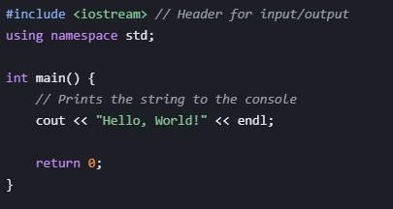

EXAMPLE

# 1

EXAMPLE # 2
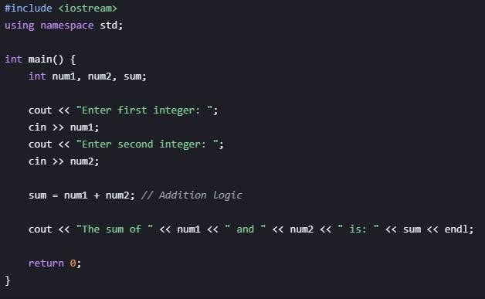

EXAMPLE # 3
